GCE Computing
Doverbroeck’s Colage
62315

Michael R. Bell
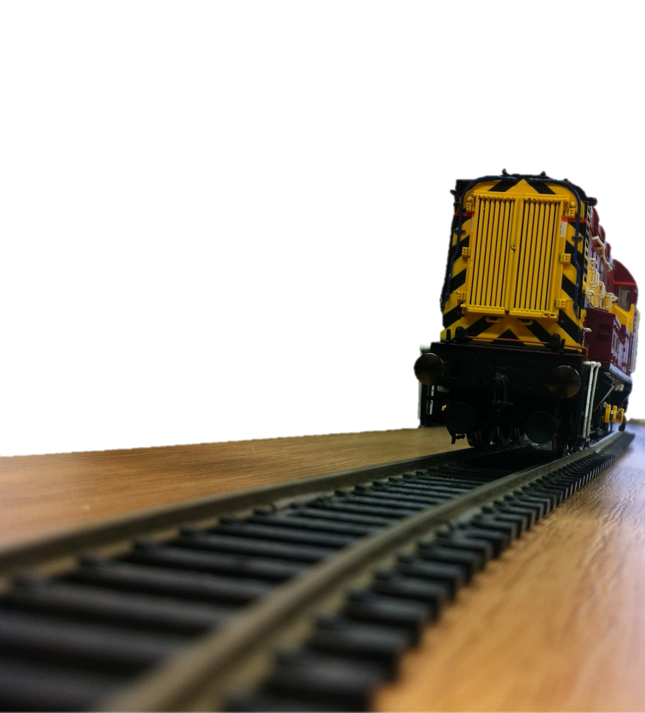
7894

[Beltrac]
Model railway automation.

Contents
words 2
words 2

words

words

words
more words

